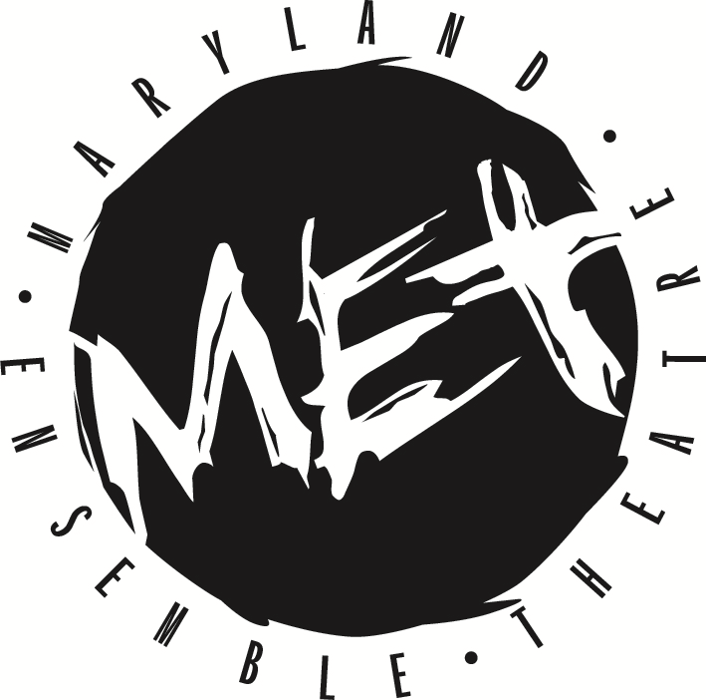
FOR IMMEDIATE RELEASE:
Kathryn Vicere
(301) 694-4744 ext. 303
kvicere@marylandensemble.org
marylandensemble.org/press

MARYLAND ENSEMBLE THEATRE
Presents
Click, Clack, Moo
By James E. Grote
September 22 - October 14
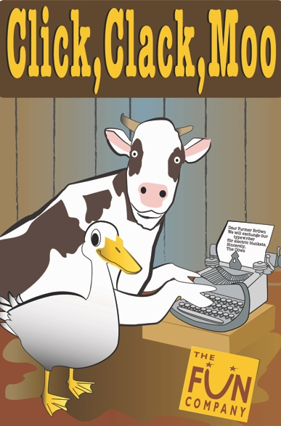

FREDERICK, MD (Aug. 30, 2018) - Maryland Ensemble Theatre’s (MET) family theatre, The Fun Company is proud to present Click, Clack, Moo. The play is adapted by James E. Grote from the beloved children’s book and recording. The original book was by Doreen Cronin, Illustrations by Betsy Lewin, Music by George Howe, Lyrics by George Howe and James E. Grote. Farmer Brown's cows are c-c-c-cold. They'd like cozy electric blankets. But how to tell him? Eureka! They discover an old typewriter in the barn and start typing away. The next day, Farmer Brown is shocked to find a rebellious note on the barn door: "Sorry. We're closed. No milk today." Uh oh, how will barnyard peace be restored? Come find out in this delightful musical adaptation of the Caldecott Honor Book by Doreen Cronin.
Click, Clack, Moo is chock-full of zany fun from start to finish. Moms, dads, brothers, sisters, and grandparents will all find something to enjoy in this colorful cast of barnyard friends. Director Jeremy Myers is thrilled at the chance to bring this beloved tale to the stage. “This title has a great recognition factor from the books, so I think this piece will really resonate with many. In Chicago, I had the pleasure of working with the adaptors, Jim Grote (script) and George Howe (music) on two other pieces they did from this series. So, I'm really happy to return to their work and bring it to Frederick!”

The Click, Clack, Moos crew includes: Director Julie Herber, Music Director Thom Huenger, Choreographer Bailey Sterling, Stage Manager Morgan Southwell, Scenic Designer Kevin Cole, Lighting Designer Doug Grove, Costume Designer Stephanie Hyder and Props Designer Maria Laird.

The cast includes: Lisa Burl and Madi Reinhold as the Cows, Susasree Das as Hen, Najee Banks as Duck and Brian Irons as Farmer Brown .

Click, Clack, Moo opens on Saturday, September 22nd and runs until Sunday, October 14th every Saturday and Sunday at 1:30 p.m. Tickets are $12. Tickets may be purchased by phone at (301) 694-4744, online at marylandensemble.org or in person at the MET box office. Come laugh it up at this barnyard adventure.

***************************************
RATING/AGE APPROPRIATE/WARNINGS: Family Friendly, ages 3+.
HOW IT BEGAN: Click, Clack, Moo: Cows That Type was published in 2000 and quickly worked its way into the hearts of children everywhere. It was developed for stage in 2009 by James E. Grote with original music by George Howe. It continues to tickle the funny bones of audiences of all ages.

PRODUCTION TEAM
Director: Jeremy Myers
Music Director: Thom Huenger
Choreographer: Bailey Sterling
Stage Manager: Morgan Southwell
Scenic Designer: Kevin Cole
Costume Designer: Stephanie Hyder
Lighting Designer: Doug Grove
Sound Designer: Thom Huenger
Prop Designer: Maria Laird

CAST
Cow 1: Lisa Burl
Cow 2: Madi Reinhold
Hen: Susasree Das
Duck: Najee Banks
Farmer Brown: Brian Irons

MARYLAND ENSEMBLE THEATRE MISSION: Maryland Ensemble Theatre (MET) is dedicated to the creation and production of extraordinary theatre art through the combined voices of a diverse ensemble of professional resident artists who are influential leaders in the community and visionaries in the art of theatre.

To learn more about MET, visit www.marylandensembletheater.org.
For the latest updates, like us on Facebook!

