FOR IMMEDIATE RELEASE:
Kathryn Vicere
(301) 694-4744 ext. 303
kvicere@marylandensemble.org
marylandensemble.org/press

MARYLAND ENSEMBLE THEATRE
Presents
Hand to God
By Robert Askins
September 7 - September 30
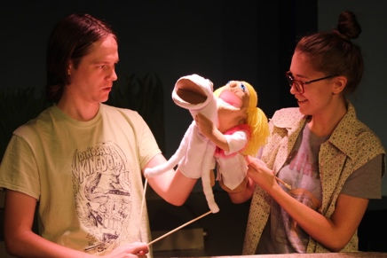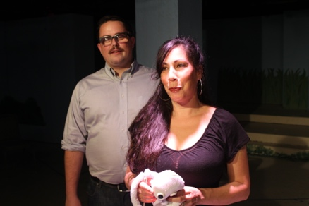

FREDERICK, MD (August 8, 2018) - Maryland Ensemble Theatre (MET) is proud to present Hand to God by Robert Askins. After his father’s death, Jason seeks solace at the Christian Puppet Ministry. His quiet life is thrown into upheaval when his puppet, Tyrone, takes on a shocking and irreverent personality of his own. Darkly delightful, Hand to God explores the startlingly fragile nature of faith, morality, and the ties that bind.
Hand to God offers a stark and unfiltered look at the uncomfortable truths of devout religion. Much like the puppets, the clever satire and witty humor will leave you in stitches. Director Tad Janes is thrilled for the opportunity to bring this play to life. “I think our audience comes to expect the unexpected from the MET. We are constantly challenging ourselves as an ensemble and our audiences by reaching for pieces of theatre that excite us. This play has some very intricate puppet work, and it's great fun to be able to pool our resources and utilize the puppetry expertise in our ensemble.”

The Hand to God crew includes: Tad Janes (Director and Sound Designer), David Allerton (Stage Manager), Spencer Barron (Assistant Stage Manager), Vanessa Strickland (Puppet Coach), Matt Vance (Scenic Designer), Doug Grove (Lighting Designer), Sherry Shaner (Costume Designer), Tabetha White (Props Designer), and Lee Hebb (Puppet Design/Construction).

The cast includes: Kevin Cole as Jason, Lauren Johnson as Jessica, Steve Custer as Timothy, Lia Seltzer as Margery, and Thom Huenger as Pastor Greg.

Hand to God opens on Friday, September 7 and runs until Sunday, September 30, Thursdays through Saturdays at 8:00 p.m. and Sundays at 3:00 p.m.. Tickets are $24 for adults and $20 for students and seniors. Tickets may be purchased by phone at (301) 694-4744, online at marylandensemble.org or in person at the MET box office. Come bust a gut at this hilariously macabre tale.

***************************************
RATING/AGE APPROPRIATE/WARNINGS: For mature audiences only.

PRODUCTION TEAM
Director: Tad Janes
Stage Manager: David Allerton
ASM: Spencer Barron
Puppet Coach: Vanessa Strickland
Scenic Designer: Matt Vance
Lighting Designer: Doug Grove
Sound Designer: Tad Janes
Costume Designer: Sherry Shaner
Props Designer: Tabetha White
Puppet Construction: Lee Hebb

CAST
Jason: Kevin Cole
Jessica: Lauren Johnson
Timothy: Steve Custer
Margery: Lia Seltzer
Pastor Greg: Thom Huenger

MARYLAND ENSEMBLE THEATRE MISSION: Maryland Ensemble Theatre (MET) is dedicated to the creation and production of extraordinary theatre art through the combined voices of a diverse ensemble of professional resident artists who are influential leaders in the community and visionaries in the art of theatre.

To learn more about MET, visit www.marylandensembletheater.org.
For the latest updates, like us on Facebook!

Photos are rehearsal shots. Production photos will be available Sep. 5. Left photo: From left Kevin Cole and Lauren Johnson. Right Photo: From left Thom Huenger and Lia Seltzer

