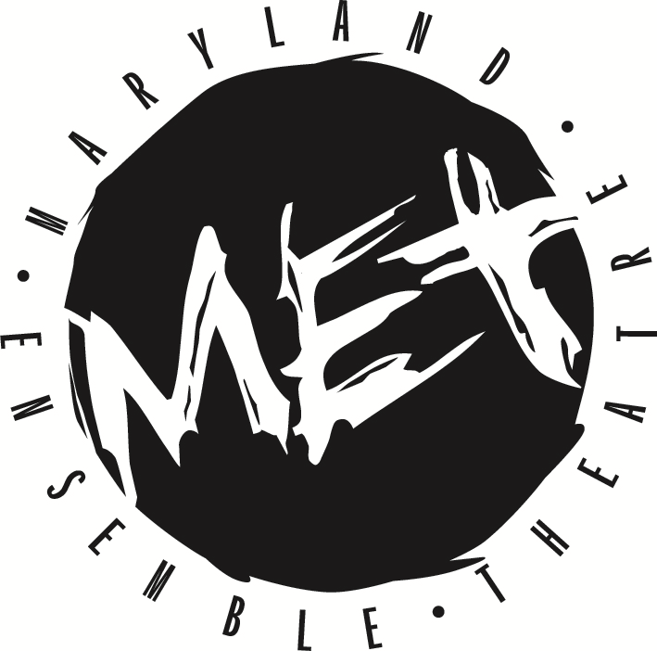
FOR IMMEDIATE RELEASE:
Kathryn Vicere
(301) 694-4744 ext. 303
kvicere@marylandensemble.org
marylandensemble.org/press

MARYLAND ENSEMBLE THEATRE
Presents
Let the Right One In
By Jack Thorne
October 19 - November 11
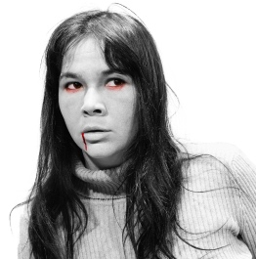

FREDERICK, MD (September 17, 2018) - Maryland Ensemble Theatre (MET) is proud to present Let the Right One In by Jack Thorne. An unlikely bond forms between a bullied schoolboy and his mysterious new neighbor … one of whom has been young for a very long time. Based on the novel of the same name by John Ajvide Lindqvist, this supernatural coming-of-age love story touches the heart and makes it race, too.
Let the Right One In was made famous by the film adaption by Tomas Alfredson, released in 2008. Since then, the story has received numerous awards and accolades, and many have praised it for its unique blend of genres and styles. Director Julie Herber was excited to breathe new life into the premise. “One of the most exciting challenges for us creating this piece is to create that sense of genre horror, while honoring the story of love, acceptance and heartbreak that are throughout. It’s a beautiful story that explores ‘other’ and ‘isolation’ and the relationships that grow out of these lonely spaces. The book and the original film will act as inspiration as well as the cinematically influenced script. I’m looking forward to finding a physical and emotional world with the cast that can express constantly shifting moods and moments,” she said

The Let the Right One In crew includes: Julie Herber (Director), Maria Laird (Stage Manager), Caitlyn Joy (Assistant Stage Manager), Cecelia Lee (Scenic Designer), Carey Rausch (Lighting Designer), Stephanie Hyder (Costume Designer), Tom Majarov (Sound Desiger), Bailey Sterling (Props Designer), and Katie Rattigan and Doug Grove (Special Effects Team).

The cast includes: Jordan Champe (Oskar), Karli Cole (Eli), Robert Leembrugen (Hakan), Brandon Richards (Jonny), Sean Byrne (Micke), Karen Heyser-Paone (Mum), Jack Evans (Mr. Avila, Halmburg), JD Sivert (Kurt, Jocke, Nils, Stefan, Dad) and Daniel Valentín-Morales (Torkel, Janne, Jimmy).

Let the Right One In opens on Friday, October 19 and runs until Sunday, November 11, Thursdays through Saturdays at 8:00 p.m. and Sundays at 3:00 p.m.. Tickets are $24 for adults and $20 for students and seniors. Tickets may be purchased by phone at (301) 694-4744, online at marylandensemble.org or in person at the MET box office. Come to fall in love with these chilling characters.

***************************************
RATING/AGE APPROPRIATE/WARNINGS: Mature Audiences
HOW IT BEGAN: The novel Let the Right One In was written in 2004 by John Ajvide Lindqvist, and since has been adapted to film by Tomas Alfredson and for theatre by Jack Thorne.

PRODUCTION TEAM
Director: Julie Herber
Stage Manager: Maria Laird
Assistant Stage Manager: Caitlyn Joy
Scenic Designer: Cecelia Lee
Lighting Designer: Carey Rausch
Costume Designer: Stephanie Hyder
Sound Designer: Tom Majarov
Properties: Bailey Sterling
Special Effects Team: Katie Rattigan and Doug Grove

CAST
Oskar: Jordan Champe
Eli: Karlie Cole
Hakan: Robert Leembrugen
Jonny: Brandon Richards
Micke: Sean Byrne
Mum: Karen Heyser-Paone
Mr. Avila/Halmburg: Jack Evans
Kurt/Jocke/Nils/Sefan/Dad: JD Sivert
Torkel/Janne/Jimmy: Daniel Valentín-Morales

MARYLAND ENSEMBLE THEATRE MISSION: Maryland Ensemble Theatre (MET) is dedicated to the creation and production of extraordinary theatre art through the combined voices of a diverse ensemble of professional resident artists who are influential leaders in the community and visionaries in the art of theatre.

To learn more about MET, visit www.marylandensembletheater.org.
For the latest updates, like us on Facebook!

