FOR IMMEDIATE RELEASE:
Kathryn Vicere
(301) 694-4744 ext. 303
kvicere@marylandensemble.org
marylandensemble.org/press

MARYLAND ENSEMBLE THEATRE
Presents
Sweat
By Lynn Nottage
September 6 - September 29

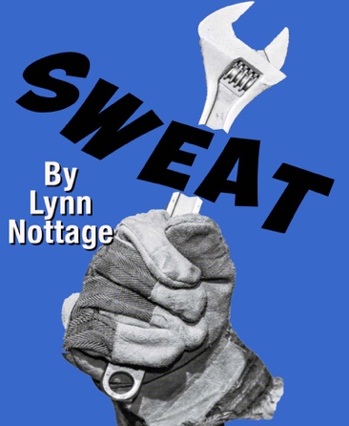

FREDERICK, MD (July 31, 2019) – Ensemble Theatre (MET) is opening it’s 22nd season with the Pulitzer Prize winning play, “Sweat,” by Lynn Nottage. In the struggling Rust Belt city of Reading, Pennsylvania, a bar becomes a battleground for race, class, family and friendship. Cynthia, Tracey, and Jessie are a group of friends with a shared history working together on the factory line. But as economic upheaval and picket lines begin to strike their lives, they find themselves pitted against each other in a desperate fight to protect their livelihood and stay afloat.

Sweat is a tale of desperation and humanity made all the more important in this current political climate. Lynn Nottage invites us to look at the all-too-familiar tale of a steel city on the decline with fresh eyes, bringing humanity and depth to the everyday people in our country who are just trying to get by. Director Gené Fouché says about this award winning piece, “Sweat is an important play. It examines the feelings of betrayal, despair and heartbreak associated with layoffs and lock outs. It holds a mirror to the deindustrialization of our country and the all too real ramifications.”

The Sweat production team includes: Director Gené Fouché, Stage Manager Melynda Burdette, Assistant Stage Manager Shayden Jamison, Scenic Designer Eric Berninghausen, Lighting Designer Doug Grove, Sound Designer Tom Majarov, Costume Designer Ben Kress, Fight Choreographer Steve Custer, Dramaturg Meghan Callis and Props Master James McGarvey.

The cast includes: Najee Banks as Chris, Ray Hatch as Brucie, Julie Herber as Tracey, Richard Johnson as Evan, Rona Mensah as Cynthia, Lia Seltzer as Jessie, Tim Seltzer as Stan, Daniel Valentín-Morales as Oscar and Liam Watkins as Jason.

Sweat opens on Friday, September 6 and runs until Sunday, September 26, Thursday through Saturdays at 8p.m. and Sundays at 3p.m. Tickets are $24 for adults, $22 for seniors and military and $16 for students with valid ID. Tickets may be purchased by phone at (301) 694-4744, online at marylandensemble.org or in person at the MET box office.

***************************************
RATING/AGE APPROPRIATE/WARNINGS: Mature Audiences

PRODUCTION TEAM
Director: Gené Fouché
Stage Manager: Melynda Burdette
Assistant Stage Manager: Shayden Jamison
Scenic Designer: Eric Berninghausen
Lighting Designer: Doug Grove
Sound Designer: Tom Majarov
Costume Designer: Ben Kress
Fight Choreographer: Steve Custer
Dramaturg: Meghan Callis
Props Master: James McGarvey.

CAST
Najee Banks
Ray Hatch
Julie Herber
Richard Johnson
Rona Mensah
Lia Seltzer
Tim Seltzer
Daniel Valentín-Moralis
Liam Watkins

MARYLAND ENSEMBLE THEATRE MISSION: MET strives to create a positive environment where artists and audience share an exciting, emotional, thought provoking theatre experience for our times and our community. MET features an eclectic season of plays that are accessible; yet, challenge audiences and pique the interest of a national audience. Through open communication and life long learning, the MET ensemble brings an unparalleled commitment to excellence that helps shape our region by initiating creative dialogue between artists and audience; providing outreach to under served communities; and training, education, and professional development opportunities to students of theatre that will propagate MET artistic values into the American Theatre.

To learn more about MET, visit www.marylandensembletheater.org.
For the latest updates, like us on Facebook!

